A project report on

ONLINE TAXI BOOKING

“KIITEASE”

***Submitted in the partial fulfillment for the award of the degree for***

***Bachelor Of Science(Computer Science)***

**Submitted By**

**NAME**

**Under the Guidance of**

**NAME,**

**AssISTANT Professor,**

**SCA KIIT,**

**Bhubaneshwar**

**SCHOOL OF COMPUTER APPLICATIONS**



**Bhubaneshwar, Odisha**

**April 2024**



**CERTIFICATE OF ORIGINALITY**

This is to certify that the project report entitled “***FITHUB (Gym Subscription Management System)”*** *was* submitted by **Name** with Roll no**. Roll-No**, final year **BSC COMPUTER SCIENCE** student in the  **School of Computer Application, KIIT Deemed to be University**, in partial fulfilment of the requirement for the award of the degree of **BACHELOR OF SCIENCE (COMPUTER SCIENCE)** is a record of an original project work carried out by them under my supervision and guidance. The project has fulfilled partial requirements as per the regulations of the institute and my opinion has reached the standard needed for submission. The results embodied in this project have not been submitted to any other university or Institute for the award of any degree or diploma.

They have worked on this project from 8th Jan 2024 to 4th April 2024 at **KIIT Deemed to be University.**

Signature of the Student Signature of the Guide

Date: …………………………. Date: …………………

Name:

**School of Computer Applications**

**KIIT University, Bhubaneswar**

Certificate

This is to certify that the project work entitled “***FITHUB(Gym Subscription Management System)”***Submitted by **Name------------** with Roll no**. ----------** is authentic and original.

Signature Signature

(Internal Examiner) (External Examiner)

Date.................. Date..................

**Declaration**

We **Name** with Roll no**. ………….** do hereby declare that the project report entitled “***FITHUB(Gym Subscription Management System)”***submitted to **the School of Computer Application, KIIT University, Bhubaneswar** for the award of the degree of **BACHELOR OF SCIENCE (COMPUTER SCIENCE)** is an authentic and original work carried out by us from 8th Jan 2024 to 4th April 2024 at KIIT University under the guidance of **External Guide Name** and **Name ……..**.

Signature of the students

Date..................

**Acknowledgement**

This satisfaction which accompanies the successful completion of any task is incomplete without the mention of that person whose hands are behind the success. Because success is the epitome of hard work, prevention, zeal, determination and the most encouraging guidance and advice serving as a beacon light and crowing our effort with success. We are grateful to **……………………………**, the special guide for his endless support and kind cooperation in the completion of this project.

Moreover, I want to acknowledge the indispensable contribution of my teammates, **------------------------------------- and ------------------------------------**. Their collaboration and dedication were fundamental to our success, and without them, our journey wouldn't have been as rewarding.

I also want to extend my thanks to the dedicated lecturers of the School of Computer Application. Over three years, they shared their expertise tirelessly, enriching our understanding and preparing us for the challenges ahead.

Lastly, I express my gratitude to the entire personnel of Campus 1, whose support and assistance have been invaluable throughout our academic journey. Together, they have played a vital role in shaping our growth and achievements.

**ABSTRACT**

Fithub is an innovative online gym subscription management system designed to streamline the operations of traditional fitness centers while providing users with seamless access to services and information. The platform offers a user-friendly interface where individuals can easily sign up, select from a range of subscription plans - including basic, standard, and premium - and conveniently book appointments. With a focus on efficiency and accessibility, Fithub caters to two primary user roles: customers and administrators.

Customers can effortlessly navigate the platform to manage their subscriptions and schedule appointments, empowering them with greater control over their fitness journey. Meanwhile, administrators wield comprehensive tools to oversee all aspects of the system. This includes the ability to view and update user details, set appointment schedules, and access valuable statistics for informed decision-making.

The core objective of Fithub is to optimize the operational processes of traditional gyms by transitioning to a cloud-based system. By centralizing data management and automating key tasks, the platform enhances efficiency, accuracy, and accessibility for both users and administrators. Fithub represents a pivotal advancement in the fitness industry, offering a modern solution to meet the evolving needs of gym management and clientele alike.

**TABLE OF CONTENTS**

(Lee & Oh, 2018)CHAPTER 1 INTRODUCTION 3

1.1. OVERVIEW 3

1.2. PROBLEM STATEMENT 3

1.3. OBJECTIVES 5

CHAPTER 2 LITERATURE REVIEW 6

2.1. Academic Journal published by SSBFNET 6

2.2. Department of Computer Science, Sam Houston State University, Huntsville, AL 77340, USA & School of Computer Science, Columbus State University, Columbus, GA 31907, USA 6

2.3. Lee, J., & Oh, C. (2018). The impact of ride-sharing on urban transportation: A literature review and directions for future research. Transportation Research Part A: Policy and Practice, 112, 134-149. 7

2.4. Zhang, Y., & Zhang, M. (2019). Examining the environmental impact of ride-hailing services: A review of current evidence and future directions. Journal of Cleaner Production, 215, 725-736. 7

2.5. Chen, Y., & Zhang, L. (2020). Understanding the social equity implications of ride-sharing: A review of empirical studies. Transportation Research Part D: Transport and Environment, 82, 102328. 8

2.6. Agatz, N., Erera, A., Savelsbergh, M., & Wang, X. (2019). Managing the operational complexity of ride-hailing services: A review and future directions. Transportation Research Part B: Methodological, 126, 696-720. 8

CHAPTER 3 SOFTWARE AND HARDWARE REQUIREMENTS 10

3.1. Design: 10

3.2 . Programming Languages 10

3.3. SPECIFIC REQUIREMENTS 12

3.4. External Interface Requirements 12

3.5. System Design 14

CHAPTER 4 DEVELOPMENT ENVIRONMENT 17

4.1 IDE and Framework 17

4.2 Backend Infrastructure 17

4.3 Cloud Services 17

4.4 Dependencies 17

4.5 Development Workflow 18

4.6. Coding 19

[4.6.1]. main.dart 19

[4.6.2]. login_screen.dart 21

[4.6.4]. kiitease_start.dart 31

CHAPTER 5 TESTING 36

CHAPTER 6 OUTPUT SCENES 39

CHAPTER 7 CONCLUSION 47

CHAPTER 8 FUTURE SCOPE OF THE PROJECT 48

CHAPTER 9 REFERENCES 49

# CHAPTER 1 INTRODUCTION

## OVERVIEW

In this globalization era, technology has been developing rapidly which has impacted the modern transportation system. Transportation has become faster like the individuals who rapidly start moving from one place to the other. In the past days due to the unavailability of the transportation system, people couldn’t travel as rapidly as today. One of the significant advancements in recent years is the enhancement of online transportation booking services which have revolutionized the way people commute in urban and suburban areas worldwide.

The traditional transportation experience, characterized by uncertainty of availability, occasional inconveniences and transparency in pricing has been redefined by the emergence of online platforms. These platforms help connect passengers with nearby drivers offering a convenient and efficient solution for getting from one point to the other.

This project explores the transformative impact of online booking services over modern transportation systems. The main of the project is to provide a convenient way of online booking for the passengers. The traditional processes are very pathetic as they are time-consuming and require a lot of human effort. However, in the online process, passengers can book according to their requirements.

Through this comprehensive analysis, the stakeholders, consumers, industry makers, and policymakers can benefit from the continued evolution of online transportation services. By understanding every aspect, we can improve transport efficiency and ultimately contribute to a more connected future.

## PROBLEM STATEMENT

* Despite the increasing demand for convenient transportation solutions, traditional taxi services often face challenges such as long wait times, lack of transparency, and inefficient booking processes.
* This project aims to develop an efficient and user-friendly online transport booking system that provides seamless booking experiences for both passengers and drivers.
* This system will address key main points in traditional services by offering features like multiple payment options, real-time vehicle tracking, user ratings, etc.
* The final goal is to enhance the overall efficiency, reliability and satisfaction of transportation services in this digital era.

## OBJECTIVES

Some of the common objectives for our project are:

* Accessibility – Makes transportation services readily available to users allowing them to book rides easily.
* Convenience – Simplify the process of booking services from various devices.
* Scalability – Design the system in such a way that there can be expansion and addition of new resources over time.
* Customer Satisfaction – Focus on delivering a positive user experience through excellent customer service and user-friendly interfaces.
* Efficiency – Improves the efficiency of transportation by optimizing routes, providing real-time tracking of vehicles and reducing wait times.
* Safety and Security – Ensures the safety of both drivers and passengers by providing some verification processes.
* Customization – Allowing users to customize their preferences like type of vehicle, no. of seats, etc.
* Community Building – Develop a good relationship between users and drivers by implementing features like ratings, reviews, etc.
* Information Security – The user gets to know about the assigned driver through the ratings and reviews of other users. This will help the user in knowing whether he/she can be comfortable or not.

# CHAPTER 2 LITERATURE REVIEW

Urban mobility has undergone a significant transformation in recent years, largely influenced by the proliferation of online transportation booking services. This literature review aims to explore various scholarly perspectives on the impact of such services on urban transportation systems, drawing insights from a diverse range of studies. By examining the literature, we seek to gain a comprehensive understanding of the challenges, opportunities, and implications associated with the integration of these services into urban mobility ecosystems.

The era of disruption has led to technological innovations that have disrupted fundamental changes in

people's lives. Unexpected changes become a phenomenon that will often appear in this era. A fight between

a conventional taxi versus an online taxi. The public had never expected before that popular motorcycle

taxis/taxis were used by the public for the benefit of human mobility and their usefulness was enhanced by

an internet-based application system. As a result, it is easier for the public to get transportation services

even at very affordable prices. Even more unexpected, online motorcycle taxi services are not limited to

alternative transportation but also extend to online delivery orders.

The era of disruption has led to technological innovations that have disrupted fundamental changes in

people's lives. Unexpected changes become a phenomenon that will often appear in this era. A fight between

a conventional taxi versus an online taxi. The public had never expected before that popular motorcycle

taxis/taxis were used by the public for the benefit of human mobility and their usefulness was enhanced by

an internet-based application system. As a result, it is easier for the public to get transportation services

even at very affordable prices. Even more unexpected, online motorcycle taxi services are not limited to

alternative transportation but also extend to online delivery orders.

Efficiency is an important element in the widespread use of the Internet. Activities within the network enable

individuals to learn more about the world. On one hand, the impact of increasingly open internet access has

been primarily used for economic exchanges. In addition to sales of goods, in recent years, internet access

has also reshaped the transportation field (Natadjaja & Setyawan, 2016).

Online transportation service is one of the newest service innovations in the e-commerce world. Online

transportation service or ride-sharing is an individual transportation service where a customer can order a

ride (car, motorcycle, etc.) through a mobile application and the driver can respond to the order through the

apps (Silalahi, Handayani, & Munajat, 2017). There are several online transportation applications found in

Indonesia such as Uber Motor, Grab-bike, Go-Jek, Blue Jeck and others. However, the three main providers

(such as Go-Jek, Grab, and Uber) are the top players in Indonesia and other big cities (Utari & Sharif, 2016)

(Silalahi, Handayani, & Munajat, 2017) (Santoso & Nelloh , 2017) (Septiani, Handayani, & Azzahro, 2017).

Ojek first appeared in Indonesia in late 1969 in Central Java and Jakarta. Ojek is a means of transportation

in the form of bicycles and then develops into a motorbike by renting passengers who rent (Lantri, Gunawan,

& Yunita, 2017). Ojek is a choice of transportation that has high flexibility. This is because

motorcycle taxis can pass places that cannot be traversed by other transportation, such as small

roads. Motorcycle taxis also have time efficiency because they can avoid traffic jams through

alternative roads. Motorcycle taxi passengers are greatly helped by this, especially for people who have high

mobility. The need for ojek is the basis for changes in the concept of the ojek itself. Ojek as a means of

transportation which is combined with the development of technology today gave birth to a technology-based

motorcycle taxi. Technology-based motorcycle taxi commonly called an online motorcycle taxi (Ojek online),

is a transformation of conventional motorcycle taxis that are combined with technology.

Online motorcycle taxis function the same as conventional motorcycle taxis in general, only the ordering and

payment system through the sophistication of the gadget / mobile device. This makes motorcycle taxi

transportation no longer considered as lower-class transportation, because online motorcycle taxi riders now

come from various economic levels, as long as they have mobile phones. The convenience offered by online

motorcycle taxis is considered troubling conventional transportation that has long been operating. Online

motorcycle taxis are ordered only through mobile phones, without having to leave the house, then just wait

and then the online motorcycle taxi will arrive and be ready to deliver. Unlike conventional motorbikes or

conventional taxis, prospective passengers must be on the side of the road waiting for a taxi or motorcycle

taxi to be called and ready to deliver or by approaching the conventional motorcycle taxi/taxi place where it

can be delivered. This practicality is the reason why they prefer online motorcycle taxis compared to

conventional transportation.

One of the online transportation applications that will be discussed in this paper is the Grab application. Grab

first operated in Indonesia in 2013. GRAB first appeared in 2011 carrying the name MyTeksi based in

Singapore, then in 2013, began expanding outside Malaysia by changing its name to Grab Taxi and finally

in 2016 to GRAB (Setyanti, 2016). GRAB is an alternative travel service in several countries in the Southeast

Asia, including Indonesia. GRAB is not the first online motorcycle taxi facility in Indonesia, but GRAB has

had rapid progress over a not-too-long period of time. Based on this, the writer wants to find out more about

the form of service provided by online transportation, especially Grab-bike and what benefits are obtained by

motorists and users regarding the development of online transportation.

Literature Review

The Age of Industrial Disruption

The era of disruption has led to technological innovations that have disrupted fundamental changes in

people's lives. Unexpected changes become a phenomenon that will often appear in this era. A fight between

a conventional taxi versus an online taxi. The public had never expected before that popular motorcycle

taxis/taxis were used by the public for the benefit of human mobility and their usefulness was enhanced by

an internet-based application system. As a result, it is easier for the public to get transportation services

even at very affordable prices. Even more unexpected, online motorcycle taxi services are not limited to

alternative transportation but also extend to online delivery orders

Efficiency is an important element in the widespread use of the internet. Activities within the network enable

individuals to learn more about the world. On one hand, the impact of increasingly open internet access has

been primarily used for economic exchanges. In addition to sales of goods, in recent years, internet access

has also reshaped the transportation field (Natadjaja & Setyawan, 2016).

Online transportation service is one of the newest service innovations in the e-commerce world. Online

transportation service or ride-sharing is an individual transportation service where a customer can order a

ride (car, motorcycle, etc.) through a mobile application and the driver can respond to the order through the

app (Silalahi, Handayani, & Munajat, 2017). There are several online transportation applications found in

Indonesia such as Uber Motor, Grab-bike, Go-Jek, Blue Jeck and others. However, the three main providers

(such as Go-Jek, Grab, and Uber) are the top players in Indonesia and other big cities (Utari & Sharif, 2016)

(Silalahi, Handayani, & Munajat, 2017) (Santoso & Nelloh , 2017) (Septiani, Handayani, & Azzahro, 2017).

Ojek first appeared in Indonesia in late 1969 in Central Java and Jakarta. Ojek is a means of transportation

in the form of bicycles and then develops into a motorbike by renting passengers who rent (Lantri, Gunawan,

& Yunita, 2017). Ojek is a choice of transportation that has high flexibility. This is because

motorcycle taxis can pass places that cannot be traversed by other transportation, such as small

roads. Motorcycle taxis also have time efficiency because they can avoid traffic jams through

alternative roads. Motorcycle taxi passengers are greatly helped by this, especially for people who have high

mobility. The need for ojek is the basis for changes in the concept of the ojek itself. Ojek as a means of

transportation which is combined with the development of technology today gave birth to a technology-based

motorcycle taxi. Technology-based motorcycle taxi commonly called an online motorcycle taxi (Ojek online),

is a transformation of conventional motorcycle taxis that are combined with technology.

Online motorcycle taxis function the same as conventional motorcycle taxis in general, only the ordering and

payment system through the sophistication of the gadget / mobile device. This makes motorcycle taxi

transportation no longer considered as lower-class transportation, because online motorcycle taxi riders now

come from various economic levels, as long as they have mobile phones. The convenience offered by online

motorcycle taxis is considered troubling conventional transportation that has long been operating. Online

motorcycle taxis are ordered only through mobile phones, without having to leave the house, then just wait

and then the online motorcycle taxi will arrive and be ready to deliver. Unlike conventional motorbikes or

conventional taxis, prospective passengers must be on the side of the road waiting for a taxi or motorcycle

taxi to be called and ready to deliver or by approaching the conventional motorcycle taxi/taxi place where it

can be delivered. This practicality is the reason why they prefer online motorcycle taxis compared to

conventional transportation.

One of the online transportation applications that will be discussed in this paper is the Grab application. Grab

first operated in Indonesia in 2013. GRAB first appeared in 2011 carrying the name MyTeksi based in

Singapore, then in 2013, began expanding outside Malaysia by changing its name to Grab Taxi and finally

in 2016 to GRAB (Setyanti, 2016). GRAB is an alternative travel service in several countries in the Southeast

Asia, including Indonesia. GRAB is not the first online motorcycle taxi facility in Indonesia, but GRAB has

had rapid progress over a not-too-long period of time. Based on this, the writer wants to find out more about

the form of service provided by online transportation, especially Grab-bike and what benefits are obtained by

motorists and users regarding the development of online transportation.

Literature Review

The Age of Industrial Disruption

The era of disruption has led to technological innovations that have disrupted fundamental changes in

people's lives. Unexpected changes become a phenomenon that will often appear in this era. A fight between

a conventional taxi versus an online taxi. The public had never expected before that popular motorcycle

taxis/taxis were used by the public for the benefit of human mobility and their usefulness was enhanced by

an internet-based application system. As a result, it is easier for the public to get transportation services

even at very affordable prices. Even more unexpected, online motorcycle taxi services are not limited to

alternative transportation but also extend to online delivery orders

The era of disruption has led to technological innovations that have disrupted or fundamental changes to

people's lives. Unexpected changes become a phenomenon that will often appear in this era. A fight between

a conventional taxi versus an online taxi. The public had never expected before that popular motorcycle

taxis/taxis were used by the public for the benefit of human mobility and their usefulness was enhanced by

an internet-based application system. As a result, it is easier for the public to get transportation services

even at very affordable prices. Even more unexpected, online motorcycle taxi services are not limited to

alternative transportation but also extend to online delivery orders

### Academic Journal published by SSBFNET

The era of disruption has led to technological innovations that have disrupted fundamental changes in people's lives. Unexpected changes become a phenomenon that will often appear in this era. A fight between a conventional taxi versus an online taxi. The public had never expected before that popular motorcycle taxis/taxis were used by the public for the benefit of human mobility and their usefulness was enhanced by an internet-based application system. As a result, it is easier for the public to get transportation services even at very affordable prices. Even more unexpected, online motorcycle taxi services are not limited to alternative transportation but also extend to online delivery orders.

**Summary:** This highlights the technological innovation, especially in the transportation system which has brought a great change in people's lives. It also discusses the advantages of online taxis over conventional taxis. These services have transformed mobility, making transportation more affordable for the public. It also notes how online motorcycles have been doing online orders.

### Department of Computer Science, Sam Houston State University, Huntsville, AL 77340, USA & School of Computer Science, Columbus State University, Columbus, GA 31907, USA

To improve the operational effectiveness of transportation systems, it is imperative to increase the use of information technology. Intelligent Transportation Systems or Smart Transportation is defined as “The application of advanced sensor, computer, electronics, and communication technologies, and management strategies in an integrated manner to improve the safety and efficiency of the surface transportation system”. Smart transportation systems improve traffic flow and safety, reducing travel times and fuel consumption. It is imperative to use IoT infrastructures more and seamlessly integrate information and communication technologies (ICT) to create a sustainable, intelligent transportation system. The implementation and application of cutting-edge communications, electronic, and computing capabilities enable information transfer, traffic flow control, and the administration of transportation networks. Four key concepts, sustainability, integration, safety, and responsiveness, are prioritized when adopting and implementing emerging technologies in transportation systems. These principles will be crucial in attaining the main goals of smart transportation, which are access and mobility, environmental sustainability, and economic development.

**Summary:** This paragraph emphasizes the use of information technology in building smart transportation services. This will lead to less fuel consumption, smooth traffic flows, good user-driver relationships, etc. There are four key concepts in adopting these services sustainability, integration, safety and responsiveness which will lead to economic development and environmental sustainability.

### Lee, J., & Oh, C. (2018). The impact of ride-sharing on urban transportation: A literature review and directions for future research. Transportation Research Part A: Policy and Practice, 112, 134-149.

Lee and Oh (2018) conducted a comprehensive literature review to examine the impact of ride-sharing services on urban transportation systems. Their analysis highlights the various ways in which ride-sharing has influenced travel behavior, congestion levels, and public transit ridership. The review synthesizes findings from empirical studies and theoretical frameworks to elucidate the complex dynamics at play. Moreover, the authors identify gaps in existing research and propose directions for future investigations, emphasizing the need for more nuanced analyses to better understand the long-term implications of ride-sharing on urban mobility.

### Zhang, Y., & Zhang, M. (2019). Examining the environmental impact of ride-hailing services: A review of current evidence and future directions. Journal of Cleaner Production, 215, 725-736.

In their review, Zhang and Zhang (2019) critically evaluate the environmental implications of ride-hailing services. Drawing on a range of empirical studies, the authors assess the extent to which ride-hailing contributes to greenhouse gas emissions, air pollution, and energy consumption in urban areas. Their analysis highlights the complex relationship between ride-hailing and environmental sustainability, pointing to both positive and negative effects. Furthermore, the review identifies research gaps related to the environmental footprint of ride-hailing and suggests avenues for future research to address these knowledge gaps and inform policy interventions aimed at mitigating environmental impacts.

### Chen, Y., & Zhang, L. (2020). Understanding the social equity implications of ride-sharing: A review of empirical studies. Transportation Research Part D: Transport and Environment, 82, 102328.

Chen and Zhang (2020) conduct a thorough review of empirical studies to examine the social equity implications of ride-sharing services. Their analysis explores how ride-sharing affects accessibility, affordability, and mobility patterns, particularly for marginalized and underserved communities. The review reveals disparities in access to ride-sharing services among different demographic groups and geographic areas, raising concerns about potential inequities. Moreover, the authors highlight the need for policies and initiatives to address these social equity challenges and ensure that ride-sharing contributes to inclusive and equitable urban transportation systems.

### Agatz, N., Erera, A., Savelsbergh, M., & Wang, X. (2019). Managing the operational complexity of ride-hailing services: A review and future directions. Transportation Research Part B: Methodological, 126, 696-720.

Agatz et al. (2019) provide a comprehensive review of the operational challenges associated with managing ride-hailing services. Their analysis examines the complexities involved in matching drivers with passengers, optimizing vehicle routing, and balancing supply and demand in real-time. The review synthesizes insights from operations research and transportation management literature to identify key issues and trends in ride-hailing operations. Additionally, the authors propose potential strategies and technological solutions to address these challenges and improve the efficiency and reliability of ride-hailing services in urban areas.

# CHAPTER 3 SOFTWARE AND HARDWARE REQUIREMENTS

The hardware and software used to develop our app based on the needs of the project and the preferences are described below.

### 3.1. Design:

**FIGMA:** Figma is a web-based tool that is used to create and share user interface (UI) designs.

* **Collaborative design**: Figma allows multiple designers to collaborate on a single project simultaneously. This is particularly useful for large projects like the online e-learning system where multiple designers may be working on different parts of the UI.
* **Prototyping**: Figma allows designers to create interactive prototypes of their designs, which can be used for user testing and feedback.
* **Design consistency**: Figma provides tools for creating and maintaining design systems, which ensure consistency across different parts of the UI and reduce design errors.
* **Easy sharing**: Figma makes it easy to share design files with other team members, stakeholders, and clients, which helps to keep everyone on the same page and reduces miscommunication.

### . Programming Languages

**FLUTTER:** Flutter is an open-source UI for software development kit created by Google. Since it operates within a single codebase and renders into native code on each platform, Flutter engineers can create native-like applications faster and with lower development costs. The importance of flutter is-

* **Efficient Development Process -** Flutter makes the development process faster and more efficient as it includes the “hot restart” and “hot reload” process which allows the user to see updates without restarting the app.
* **Widgets and Compatibility –** Widgets are the building blocks of the app. They are ready-made and through these widgets, everything can be created.
* **High Performance -** Flutter doesn’t use a bridge to communicate between the app and the platform. We get a faster-starting app with beautiful, fast animations and fewer performance problems.

**Dart:** It forms the foundation of Flutter. Dart also supports many core developer tasks like formatting, analysing, and testing code.

The significance of dart in flutter is:

* Dart is designed to be the best companion for Flutter. It helps developers to create powerful and high-performance mobile, web, and desktop applications.
* Dart's performance contributes to Flutter's ability to create fast and responsive user interfaces. This is important in mobile app development, where users expect apps to run faster and more smoothly.
* Using Dart in Flutter means that developers only need to learn one language to create apps for various platforms like Android, iOS, web, and desktop
* Dart with Flutter offers a hot reload feature. Due to this feature developers can instantly see their code changes without restarting the whole app.
* Flutter uses a widget-based architecture, and Dart helps define these widgets. So, it is very easy to develop complex and attractive user interfaces.

### 3.3. SPECIFIC REQUIREMENTS

**3.3.1. Document Purpose**:

This SRS document is intended to be used by software developers, designers, and testers who are involved in the development and testing of the system. This document provides a detailed overview of the system scope, functional and non-functional requirements, and other important aspects of the system design and development. This document will serve as a benchmark for testing and evaluating the system and also as a reference for the development team and stakeholders to ensure that the system is developed according to the requirements and specifications outlined in the document.

**3.3.2. Definitions, Acronyms and Abbreviations Definitions:**

* Users: Student, Faculty, Management, Admin.
* Admin: Application administrator responsible for application management.
* Management: Registered users who manage the entire working of KIITEASE.
* Faculty: Registered teachers of KIITEASE to teach the students studying in KIITEASE.
* Students: Registered users of KIITEASE as the students of the classroom.

**3.3.3. Acronyms and Abbreviations:**

* SRS: Software Requirement Specification
* DFD: Data Flow Diagram
* ER: Entity Relationship
* RAM: Random Access Memory
* Wi-Fi: Wireless Fidelity

### External Interface Requirements

**3.4.1. Hardware Interfaces:**

The system will require a modern computer or mobile device with an internet connection to access it. The additional hardware necessary for participation in the sessions is a computer headset (combination of headphones and a microphone), webcam (optional) and a minimum of 512Kbs of bandwidth internet.

**3.4.2. Software Interface:** The system will be compatible with modern web browsers, including Google Chrome, Mozilla Firefox, Safari, and Microsoft Edge. Overall, the list of Hardware and Software Requirements at the user end is generalized in the table below.

|  |  |
| --- | --- |
| **NAME OF COMPONENT** | **SPECIFICATION** |
| **Processor** | **Desktop/Laptop:**   * Intel core processor or better performance   **Mobile/Tablet:**   * Any processor with good performance |
| **Memory** | **Desktop/Laptop:**   * 8GB RAM or more   **Mobile/Tablet:**   * 2GB RAM or more |
| **Operating System** | **Desktop/Laptop:**   * Windows 7/10/11, Linux,   **Mobile/Laptop:**   * IOS or Android |
| **Browser** | **Desktop/Laptop:**   * Any of Chrome, Mozilla, Opera, etc.   **Mobile/Laptop:**   * Chrome, Safari, Opera, etc. |

**3.4.3. FUNCTIONAL REQUIREMENTS**

* **User Registration and Authentication-** Users should be able to log in to the system with their details and log in securely.
* **Search and Booking-** The user should be able to search for the vehicle according to his/her requirements and should be able to book their chosen vehicle.
* **Multiple Transport Modes-** The user should be able to choose between different modes of vehicles like taxis, bikes, etc.
* **Availability and Scheduling-** Users should be able to view the availability of the transport system according to their desired time and place.
* **Payment Processing-** Integration with payment gateways to facilitate secure payment processing.
* **User Profile Management-** User should be able to manage their profiles, update their password and view their booking history.

**3.4.4. NON-FUNCTIONAL REQUIREMENTS**

* **Performance-** The system should have fast booking, searching and accessing information with minimal latency.
* **Reliability-** The system should be highly available for maintenance and upgrades. The system should support backup recovery and disaster management.
* **Security-** It should implementencryption for data storage and transmission**,** secure authentication mechanisms and protect user data including personal details and passwords.
* **Maintainability-** The system should be designed with well-documented codes for future enhancements.
* **Usability-** The user interface should be user-friendly and the system should provide clear feedback to users on their actions like booking, etc.

### 3.5. System Design

Design is a meaningful engineering representation of something that is to be built. Software design is a process through which the requirements are translated into a representation of the software. Design is the perfect way to accurately translate a customer’s requirement into a finished software product. In our project, we have used two diagrams to represent the implementation of the system.

* Data Flow Diagram
* Entity Relationship Diagram

**3.5.1 DFD(DATA FLOW DIAGRAM)**

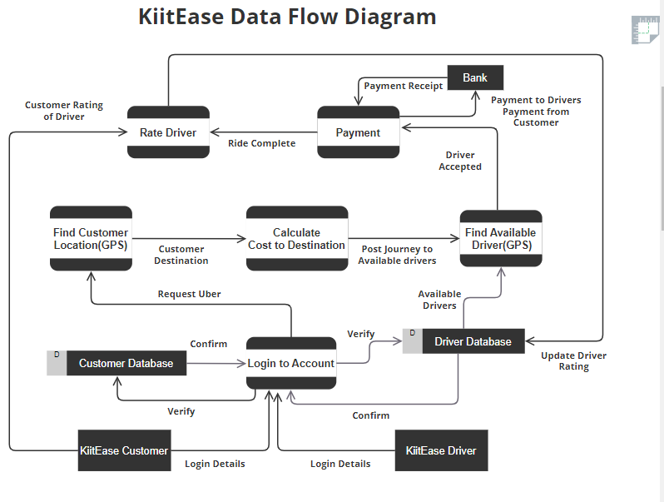**3.5.2. ER DIAGRAM**

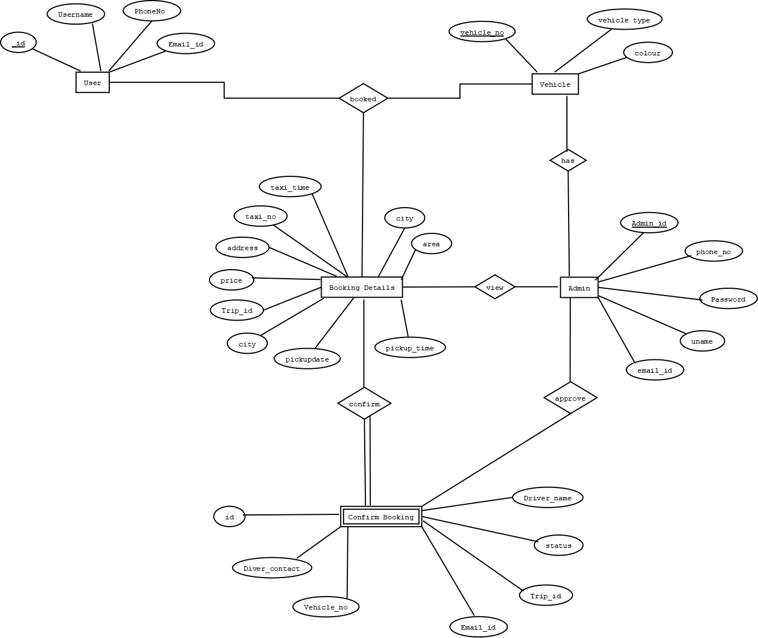

# CHAPTER 4 DEVELOPMENT ENVIRONMENT

## 4.1 IDE and Framework

The development of the KIITEASE online taxi booking platform was primarily carried out using the Android Studio Integrated Development Environment (IDE) with Flutter framework. Flutter, an open-source UI toolkit created by Google, provided the foundation for building cross-platform applications with a single codebase. Leveraging Flutter allowed for efficient development and ensured native-like performance on both Android and iOS platforms.

## 4.2 Backend Infrastructure

The backend infrastructure of KIITEASE relied on Firebase, a comprehensive platform provided by Google, for authentication and database management. Firebase Authentication facilitated secure user authentication, ensuring that only authorized users could access the platform's features. Firebase Realtime Database served as the backend database, enabling real-time synchronization of data across clients and ensuring seamless communication between the application frontend and backend.

## 4.3 Cloud Services

To access additional services crucial for the functionality of the application, such as mapping and geolocation, KIITEASE integrated with Google Cloud Platform (GCP). Google Maps Platform APIs, including Geocoding, Directions, and Places, were utilized to enable features such as real-time vehicle tracking, route optimization, and location-based searching. These services enhanced the user experience and provided essential functionalities for both passengers and drivers.

## 4.4 Dependencies

The development of KIITEASE involved the integration of several dependencies to extend the capabilities of the Flutter framework and facilitate seamless interaction with backend services. Some of the key dependencies utilized in the project include:

* **cupertino_icons:** Provides access to Cupertino icons for iOS app design consistency.
* **firebase_core, firebase_auth, firebase_database:** Firebase SDKs for core functionality, authentication, and database operations.
* **fluttertoast:** Enables the display of toast messages for user notifications.
* **google_maps_flutter:** Facilitates the integration of Google Maps into the application for interactive mapping features.
* **dio:** A powerful HTTP client for making network requests and handling responses.
* **flutter_polyline_points:** Used for decoding polylines from Google Maps API responses to render routes.
* **geolocator:** Allows access to device location information for real-time tracking and geolocation-based services.
* **http:** Provides HTTP client capabilities for network communication.
* **provider:** Implements the provider pattern for state management, ensuring efficient data flow within the application.
* **flutter_geofire:** Integration with GeoFire for efficient location-based querying and proximity searches.
* **smooth_star_rating_nsafe:** Enables the implementation of smooth star rating widgets for user feedback and ratings.

These dependencies played a crucial role in enhancing the functionality, performance, and user experience of the KIITEASE application, ensuring a seamless and feature-rich experience for both passengers and drivers.

## 4.5 Development Workflow

The development workflow of KIITEASE followed an iterative and collaborative process, with a focus on continuous integration and deployment. Developers collaborated within the Android Studio IDE, utilizing version control systems such as Git for efficient code management and collaboration. Continuous integration and deployment pipelines were established to automate the build, testing, and deployment processes, ensuring rapid iteration and delivery of new features and updates to users.

## 4.6. Coding

### [4.6.1]. main.dart

import 'package:firebase_core/firebase_core.dart';

import 'package: flutter/material.dart';

import 'package:mobile1/mainScreen/kiitease_start.dart';

import 'package:mobile1/splashscreen/splash_screen.dart';

import 'firebase_options.dart';

Future<void> main() async

{

WidgetsFlutterBinding.ensureInitialized();

await Firebase.initializeApp(

options: DefaultFirebaseOptions.currentPlatform,

);

runApp(

MyApp(

child: MaterialApp(

title: 'Drivers App',

theme: ThemeData(

primarySwatch: Colors.blue,

),

home: const Start_Screen(),

debugShowCheckedModeBanner: false,

)

),

);

}

class MyApp extends StatefulWidget {

final Widget? child;

MyApp({this.child});

static void restartApp(BuildContext context){

context.findAncestorStateOfType<_MyAppState>()!.restartApp();

}

@override

State<MyApp> createState() => _MyAppState();

}

class _MyAppState extends State<MyApp> {

// This widget is the root of your application.

Key = UniqueKey();

void restartApp(){

setState(() {

key = UniqueKey();

});

}

@override

Widget build(BuildContext context) {

return KeyedSubtree(

key: key,

child: widget.child!,

);

}

}

### [4.6.2]. login_screen.dart

import 'package:firebase_auth/firebase_auth.dart';

import 'package:firebase_database/firebase_database.dart';

import 'package:flutter/material.dart';

import 'package:fluttertoast/fluttertoast.dart';

import 'package:mobile1/authentication/signup_screen.dart';

import 'package:mobile1/global/global.dart';

import 'package:mobile1/mainScreen/main_screen.dart';

import 'package:mobile1/splashscreen/splash_screen.dart';

import 'package:mobile1/widget/progress_dialogue.dart';

class LoginScreen extends StatefulWidget

{

@override

State<LoginScreen> createState() => _LoginScreenState();

}

class _LoginScreenState extends State<LoginScreen> {

TextEditingController passwordTextEditingController = TextEditingController();

TextEditingController emailTextEditingController = TextEditingController();

validateForm()

{

if(!emailTextEditingController.text.contains("@"))

{

Fluttertoast.showToast(msg: "Email address is not Valid.");

}

else if(passwordTextEditingController.text.isEmpty)

{

Fluttertoast.showToast(msg: "Password is required.");

}

else

{

loginDriverNow();

}

}

loginDriverNow() async

{

showDialog(

context: context,

barrierDismissible: false,

builder: (BuildContext c)

{

return ProgressDialog(message: "Processing, Please wait...",);

}

);

final User? firebaseUser = (

await fAuth.signInWithEmailAndPassword(

email: emailTextEditingController.text.trim(),

password: passwordTextEditingController.text.trim(),

).catchError((msg){

Navigator.pop(context);

Fluttertoast.showToast(msg: "Error: " + msg.toString());

})

).user;

if(firebaseUser != null)

{

DatabaseReference driversRef = FirebaseDatabase.instance.ref().child("drivers");

driversRef.child(firebaseUser.uid).once().then((driverKye){

final snap= driverKye.snapshot;

if (snap.value != null){

currentFirebaseUser = firebaseUser;

Fluttertoast.showToast(msg: "Login Successful.");

Navigator.push(context, MaterialPageRoute(builder: (c)=> const MySplashScreen()));

} else {

Fluttertoast.showToast(msg: "No record exist with this email");

fAuth.signOut();

Navigator.push(context, MaterialPageRoute(builder: (c)=> const MySplashScreen()));

}

});

}

else

{

Navigator.pop(context);

Fluttertoast.showToast(msg: "Error Occurred during Login.");

}

}

@override

Widget build(BuildContext context) {

return Scaffold(

backgroundColor: Colors.black54,

body: SingleChildScrollView(

child: Padding(

padding: const EdgeInsets.all(20.0),

child: Column(

children: [

const SizedBox(height: 10,),

Padding(

padding: const EdgeInsets.all(20.0),

child: Image.asset("asset/logo1.png"),

//child:Image.network('https://picsum.photos/250?image=9')

),

const SizedBox(height: 10,),

const Text(

"Sign in as a Driver",

style: TextStyle(

fontSize: 24,

color: Colors.grey,

fontWeight: FontWeight.bold

),

),

TextField(

controller: emailTextEditingController,

keyboardType: TextInputType.emailAddress,

style: const TextStyle(

color: Colors.grey

),

decoration: const InputDecoration(

labelText: "Email",

hintText: "email@example.com",

enabledBorder: UnderlineInputBorder(

borderSide: BorderSide(color: Colors.grey),

),

focusedBorder: UnderlineInputBorder(

borderSide: BorderSide(color: Colors.grey),

),

hintStyle: TextStyle(

color: Colors.grey,

fontSize: 10,

),

labelStyle: TextStyle(

color: Colors.grey,

fontSize: 14,

),

),

),

TextField(

controller: passwordTextEditingController,

keyboardType: TextInputType.text,

obscureText: true,

style: const TextStyle(

color: Colors.grey

),

decoration: const InputDecoration(

labelText: "Password",

hintText: "Password",

enabledBorder: UnderlineInputBorder(

borderSide: BorderSide(color: Colors.grey),

),

focusedBorder: UnderlineInputBorder(

borderSide: BorderSide(color: Colors.grey),

),

hintStyle: TextStyle(

color: Colors.grey,

fontSize: 10,

),

labelStyle: TextStyle(

color: Colors.grey,

fontSize: 14,

),

),

),

const SizedBox(height: 20,),

//Image.network('https://picsum.photos/250?image=9'),

ElevatedButton(

style: ElevatedButton.styleFrom(

backgroundColor: Colors.lightBlue,

),

onPressed: (){

validateForm();

},

child: Text(

"Login",

style: TextStyle(

color: Colors.black54,

fontSize: 18,

),

),

),

TextButton(

onPressed: (){

Navigator.push(context, MaterialPageRoute(builder: (c)=> SignUpScreen()));

},

child: const Text(

"Don't have an account yet? Signup Here",

style: TextStyle(

fontStyle: FontStyle.italic,

fontWeight: FontWeight.bold,

fontSize: 13.0,

),

),

),

],

),

),

),

);

}

}

**[4.3]. main_screen.dart**

import 'package:flutter/material.dart';

import 'package:mobile1/tabPages/earning_tab.dart';

import 'package:mobile1/tabPages/home_tab.dart';

import 'package:mobile1/tabPages/profile_tab.dart';

import 'package:mobile1/tabPages/ratings_tab.dart';

class MainSceen extends StatefulWidget {

const MainSceen({super.key});

@override

State<MainSceen> createState() => _MainSceenState();

}

class _MainSceenState extends State<MainSceen> with SingleTickerProviderStateMixin

{

TabController? tabController;

int selectdIndex = 0;

onItemClicked(int index){

setState(() {

selectdIndex = index;

tabController!.index = selectdIndex;

});

}

@override

void initState(){

super.initState();

tabController = TabController(length: 4, vsync:this);

}

@override

Widget build(BuildContext context) {

return Scaffold(

backgroundColor: Colors.grey[300],

body: TabBarView(

physics: NeverScrollableScrollPhysics(),

controller: tabController,

children: const [

HomeTabPage(),

EarningsTabPage(),

RatingsTabPage(),

ProfileTabPage(),

],

),

bottomNavigationBar: BottomNavigationBar(

items: const [

BottomNavigationBarItem(

icon: Icon(Icons.home),

label: "Home",

),

BottomNavigationBarItem(

icon: Icon(Icons.credit_card),

label: "Earnings",

),

BottomNavigationBarItem(

icon: Icon(Icons.star),

label: "Ratings",

),

BottomNavigationBarItem(

icon: Icon(Icons.person),

label: "Account",

),

],

unselectedItemColor: Colors.white54,

selectedItemColor: Colors.white,

backgroundColor: Colors.black38,

type: BottomNavigationBarType.fixed,

showSelectedLabels: true,

currentIndex: selectdIndex,

onTap: onItemClicked,

),

);

}

}

### [4.6.4]. kiitease_start.dart

import 'package:flutter/material.dart';

import 'package:mobile1/splashscreen/splash_screen.dart';

class Start_Screen extends StatefulWidget {

const Start_Screen({super.key});

@override

State<Start_Screen> createState() => _Start_ScreenState();

}

class _Start_ScreenState extends State<Start_Screen> {

@override

Widget build(BuildContext context) {

return Scaffold(

backgroundColor: Colors.grey,

body: Column(

mainAxisAlignment: MainAxisAlignment.center,

children: [

SizedBox(height: 340,),

Column(

mainAxisAlignment: MainAxisAlignment.center,

children: [

Center(

child: Column(

mainAxisAlignment:MainAxisAlignment.center,

children: [

Container(

child: ElevatedButton(

style: ElevatedButton.styleFrom(

backgroundColor:Colors.black54,

shape: RoundedRectangleBorder(

borderRadius: BorderRadius.circular(10.0), // Adjust border radius as needed

),

padding: EdgeInsets.only(left: 20, top: 40, bottom: 40, right: 20)

// Adjust padding as needed

),

child: Text(

"KIITEASE",

style: TextStyle(

color: Colors.white,

fontSize: 14,

),

),

onPressed: (){

Navigator.push(context, MaterialPageRoute(builder: (c)=> MySplashScreen()));

},

),

),

SizedBox(height: 10,),

Container(

child: Row(

mainAxisAlignment: MainAxisAlignment.center,

children: [

Text(

"Travel With Safety",

style: TextStyle(

color: Colors.black,

fontSize: 14,

fontWeight: FontWeight.bold,

),

),

SizedBox(width: 4,),

Icon(Icons.safety_check)

],

),

),

]

),

),

],

),

// SizedBox(height: 300,),

Expanded(

child: Column(

mainAxisAlignment: MainAxisAlignment.end,

children: [

Container(

margin: EdgeInsets.all(20.0),

child: ElevatedButton(

style: ElevatedButton.styleFrom(

backgroundColor: Colors.black54,

// shape: RoundedRectangleBorder(

// borderRadius: BorderRadius.circular(10.0), // Adjust border radius as needed

// ),

// Adjust padding as needed

),

child: Row(

mainAxisAlignment: MainAxisAlignment.center,

children: [

Text(

"Get Started",

style: TextStyle(

color: Colors.white,

fontSize: 14,

),

),

SizedBox(width: 10,),

Icon(

Icons.arrow_circle_right,

color: Colors.white,

)

],

),

onPressed: (){

Navigator.push(context, MaterialPageRoute(builder: (c)=> MySplashScreen()));

},

),

),

],

),

),

]

),

);

}

}

# CHAPTER 5 TESTING

Software testing is the process which checks for errors and gaps and finds out whether the application meets the desired expectations or not before the application is installed and goes live.

Testing is important because of the following reasons :-

* **Identifies defects early**- It identifies issues and defects with the written code so that they can be fixed before the software is delivered.
* **Increases customer trust and satisfaction** -Testing a product through its development cycle builds customer trust and satisfaction as it identifies the strong and weak points of the application.
* **Saves Money**- The issues that go unnoticed due to lack of software testing can cause bigger price tags for the organization. It can be more expensive and complicated to resolve the issue after the application launches.
* **Helps with scalability**- It is done to find out how well an application scales with increasing workloads such as data volume, user traffic, etc.
* **Bug-free application**- The main task of software testing is to identify bugs and inform the concerned developing team about it. After fixing the bug, the team again rechecks the bug for its status.
* **Speed up development process-** Software testing helps the development team speed up the development process by detecting defects.

**Unit Testing:**

Unit testing involves the design of test cases that validate that the internal program logic is functioning properly and that program inputs produce valid outputs. All decision branches and internal code flow should be validated. It is the testing of individual software units of the application.it is done after the completion of an individual unit before integration.

**Functional testing:**

Functional tests provide systematic demonstrations that functions tested are available as specified by the business and technical requirements, system documentation, and user manuals. It ensures all the features are working as expected like searching for routes, booking tickets, etc.

**System Test**

System testing ensures that the entire integrated software system meets requirements. It tests a configuration to ensure known and predictable results. An example of system testing is the configuration-oriented system integration test. System testing is based on process descriptions and flows, emphasizing pre-driven process links and integration points.

**White Box Testing**

White Box Testing is a testing in which the software tester knows the inner workings, structure and language of the software or at least its purpose. It is purpose. It is used to test areas that cannot be reached from a black box level.

**Black Box Testing**

Black Box Testing is testing the software without any knowledge of the inner workings, structure or language of the module being tested. Black box tests, like most other kinds of tests, must be written from a definitive source document, such as specification or requirements document, such as specification or requirements document. It is a testing in which the software under test is treated, as a black box You cannot “see” into it. The test provides inputs and responds to outputs without considering how the software works.

**Unit Testing:**

Unit testing is usually conducted as part of a combined code and unit test phase of the software lifecycle, although it is not uncommon for coding and unit testing to be conducted as two distinct phases.

**Performance Testing**:

It includes verifying the system’s responsiveness and load times during peak periods.

**Security Testing**:

Testing for vulnerabilities such as unauthorized access and payment security.

**Localization Testing**:

Testing the system’s adaptability to different languages, regional preferences, etc.

**Regression Testing**:

Checking previously fixed issues so that they don’t reoccur after new upgrades.

**Usability Testing**:

It includes assessing the system’s user-friendliness including ease of navigation, clarity of instructions, etc.

**Compatibility Testing**:

It ensures that the system works across different devices like desktops, laptops, phones and web browsers.

**Accessibility Testing**:

Check if the system is accessible to users with disabilities and how well the system fits with the guidelines.

# CHAPTER 6 OUTPUT SCENES

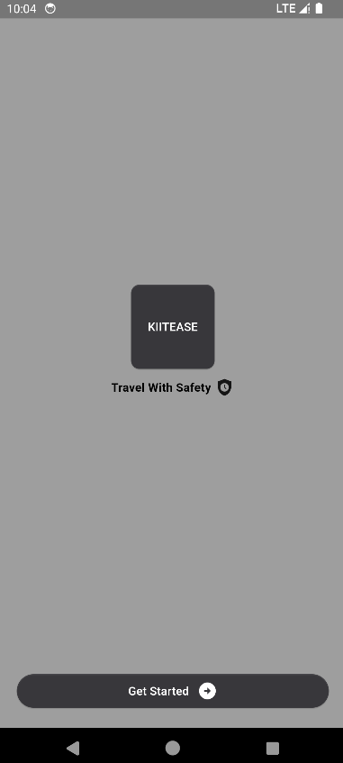**Driver’s App**

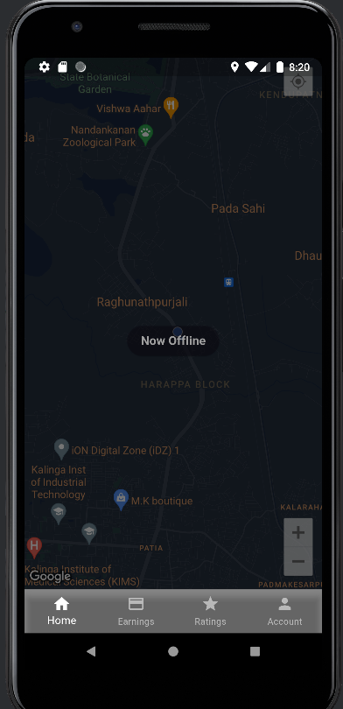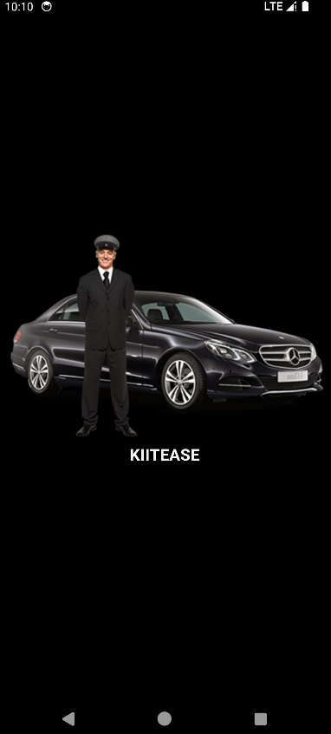

When the driver initiates the app, they are automatically logged in. If they wish to become available to receive ride requests, they simply tap the "Go Online" button. It's important to note that every driver must first create an account and provide their details before accessing the app's features.

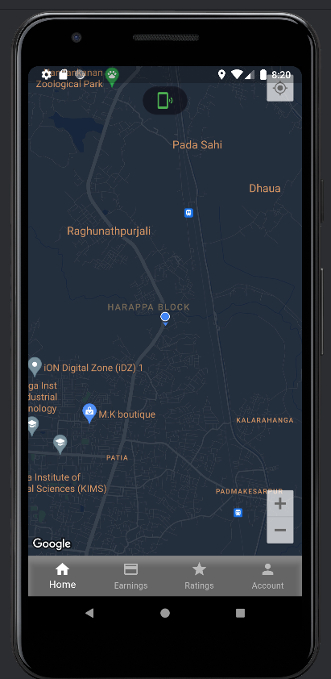

It's In this scenario, the driver is already online, making them visible to users on the screen among the nearest available drivers. From this point, passengers can proceed to request a ride directly from the driver displayed on their app interface.

**User’s App (Passenger)**

Here the user can easily input the drop off location. Without specifying the drop off location, the user cannot request a ride.

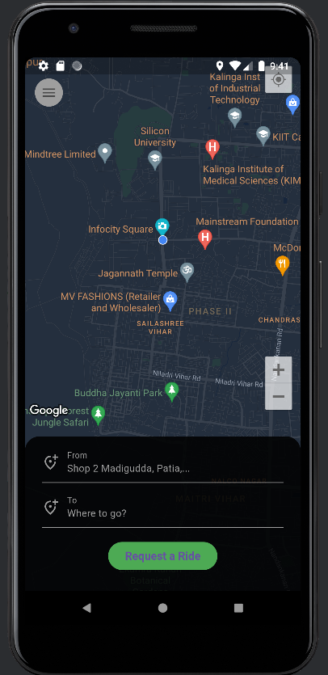

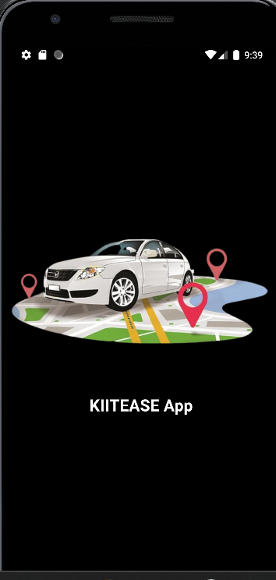

**User’s App (Passenger)**

On the other hand, passengers access the user's app, where they are greeted with the home screen. Before proceeding, passengers are required to sign up and provide necessary details. Once logged in, passengers remain logged in until they choose to log out.

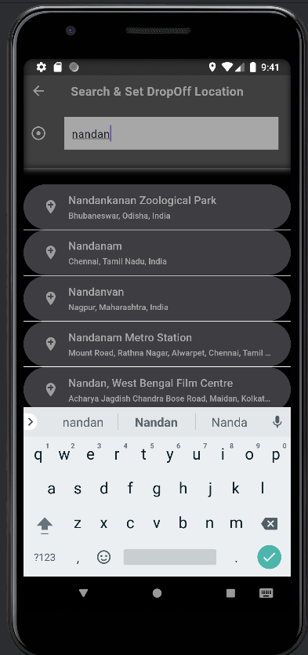

**User’s App (Passenger)**

As the user begins inputting the drop-off location, the app offers suggestions matching the words being typed. This feature simplifies the process, allowing users to effortlessly select a suggested location by clicking on it. Once selected, this chosen location becomes the designated drop-off point for the trip.

**User’s App (Passenger)**

After selecting the drop-off location, the app generates a polyline from the user's current location to the chosen drop-off address. At this point, users have the option to request a ride by sending a request to one of the nearest available drivers. This initiates the process of matching the user with a driver who can fulfill the ride request.the user begins inputting the drop-off location, the app offers suggestions matching the words being typed. This feature simplifies the process, allowing users to effortlessly select a suggested location by clicking on it. Once selected, this chosen location becomes the designated drop-off point for the trip.

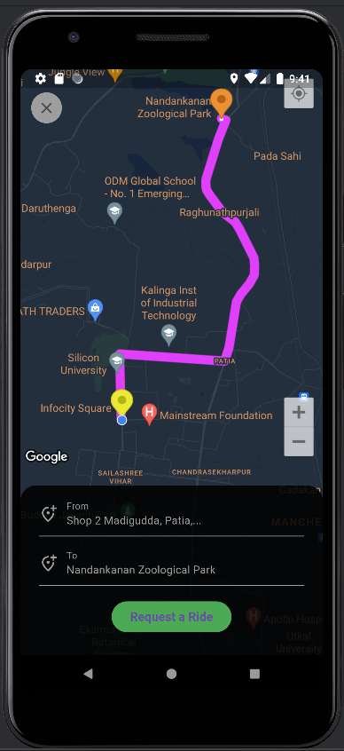

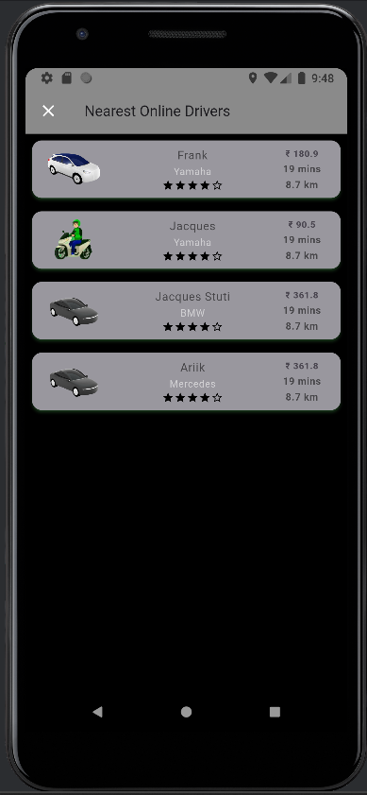

**User’s App (Passenger)**

This screen provides a visual representation of the nearest drivers who are currently online, along with essential details such as the price, driver's name, distance to travel, and the type of taxi available. Users can browse through this list and select their preferred driver. Upon selection, a notification is promptly sent to the chosen driver, alerting them of the ride request. This seamless interaction streamlines the process of connecting users with available drivers, enhancing the overall user experience.

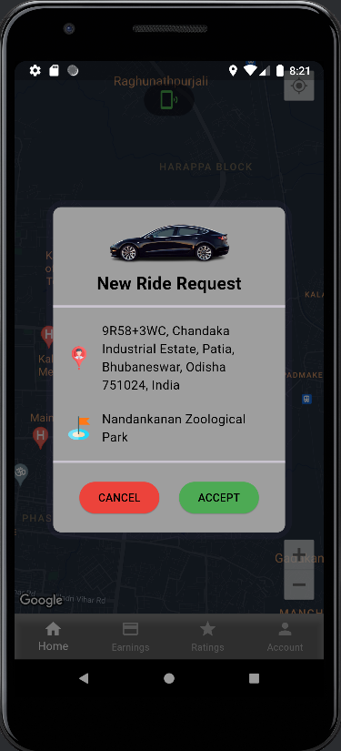

**Driver’s App (Passenger)**

When a ride request notification pops up on the driver's screen, they're given the option to either accept or decline it. If they choose to decline, no worries – the notification will then be sent back to the user, so they can try another driver. But if the driver accepts the request, that's when the real magic happens! The app instantly maps out a route from the driver's current location straight to the user's pickup spot, showing the estimated time remaining right there on the screen. It's all about making sure both the driver and the user are on the same page and ready to roll.

**Driver’s App (Passenger)**

As the driver accepts the ride request, the app initiates a dynamic process. First, it meticulously plots a route from the driver's current location to the user's designated pickup spot, illustrating the path with a clear and concise polyline on the map interface. Alongside this visual aid, the app provides invaluable real-time information, displaying the estimated time remaining for the driver to arrive at the pickup location. Moreover, the app's map interface offers an immersive experience by continuously updating the driver's location in real time as they navigate towards the pickup point. When the driver arrives at the user’s location, he clicks on the button “Arrived” to notify the user

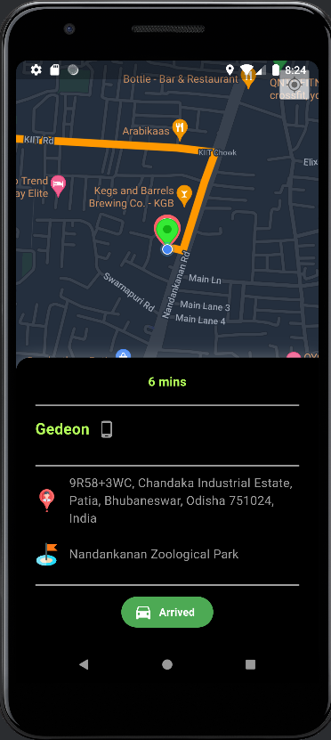

**Driver’s App (Passenger)**

Upon arrival at the user's designated pickup location, the driver is prompted with a pivotal moment: the "Let's Go" button. This signifies the transition from anticipation to action, as both driver and passenger prepare to embark on their journey together. Once the user has settled comfortably into the taxi, the driver simply clicks on this button, signaling that they are ready to commence the trip.

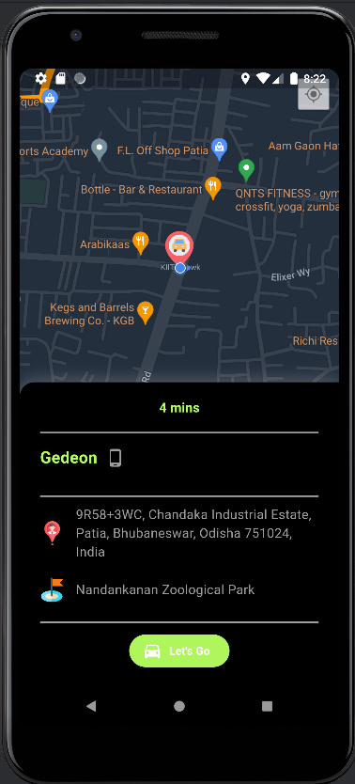

**Driver’s App (Passenger)**

After the "Let's Go" button is clicked and the driver initiates the trip, the screen undergoes a transformative shift. Now, it becomes an immersive navigation hub, showcasing the route ahead and the real-time location of the taxi. As the journey unfolds, the app continuously updates the polyline, tracing the path along with dynamic accuracy. This real-time tracking isn't just about visualization; it's a window into the journey's progression. Users are kept informed of the remaining minutes to their destination, fostering anticipation and ensuring seamless planning. This immersive experience persists until the moment of arrival, when the driver can then initiate the culmination of the trip by clicking on the "End Trip" button.

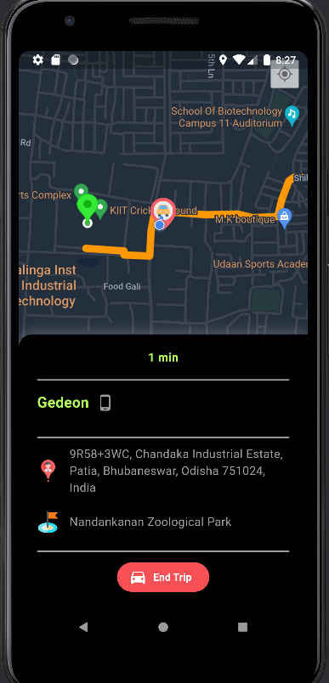

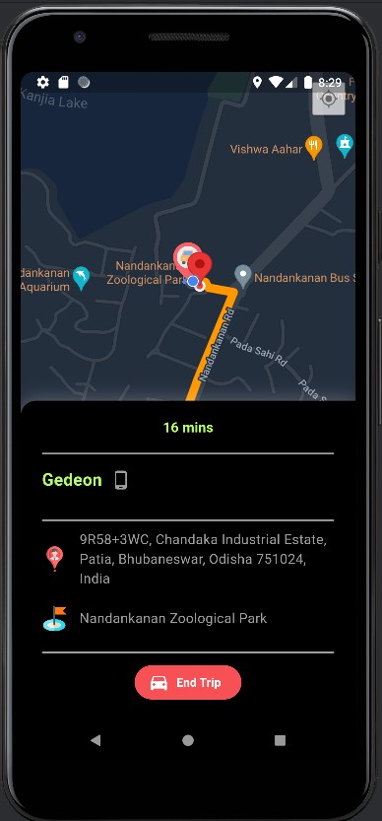

**Driver’s App (Passenger)**

Upon reaching the drop-off location, the driver has the option to finalize the trip by clicking on the "End Trip" button. Subsequently, the amount to be paid by the user will appear on the screen. To confirm receipt of the payment, the driver simply needs to click on the "Receive Cash" button.

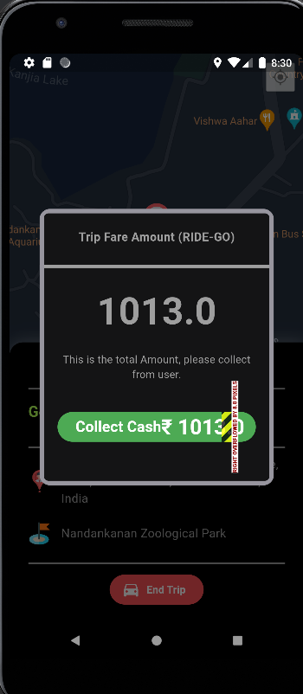

# CHAPTER 7 CONCLUSION

The development of the KIITEASE app marks a significant milestone in addressing the challenges and inefficiencies inherent in traditional transportation systems. Through the utilization of cutting-edge technology and innovative approaches, KIITEASE has successfully provided a solution that enhances accessibility, convenience, and efficiency for both passengers and drivers.

By offering seamless booking experiences, real-time vehicle tracking, multiple payment options, and user ratings, KIITEASE aims to redefine the way people commute in urban and suburban areas. The project's objectives, including accessibility, convenience, scalability, customer satisfaction, efficiency, safety, and community building, have been meticulously addressed through comprehensive research, analysis, and implementation.

Moreover, the literature review underscores the transformative impact of online transportation services globally, with particular emphasis on the rapid progression of services like Grab in regions such as Indonesia. The convenience and practicality offered by online motorcycle taxis have not only disrupted conventional transportation methods but also democratized access to mobility, benefiting users across various economic strata.

The adoption of modern tools and technologies such as Figma for design and Flutter with Dart for app development reflects a commitment to efficiency, performance, and user experience. Furthermore, the project's adherence to stringent software and hardware requirements ensures robustness, reliability, and security, essential for delivering a seamless and trustworthy service to users.

As we move forward, continuous efforts in enhancing performance, reliability, security, and user experience will remain pivotal. KIITEASE is poised to contribute significantly to the evolution of transportation systems, fostering a more connected and efficient future. With a focus on innovation, adaptability, and responsiveness to user needs, KIITEASE is well-positioned to thrive in the dynamic landscape of modern transportation services.

# CHAPTER 8 FUTURE SCOPE OF THE PROJECT

In the future, there is great potential to further enhance the application. Some of them are:

* One possible direction is to incorporate more interactive features such as AI(Artificial Intelligence) and ML(Machine Learning) to enhance user experience, optimize routes, etc.
* The services can also be expanded like adding alternative modes of transport like electric scooters.
* We can also enhance the service coverage to reach more regions according to the public demand.
* We can integrate advanced authentication methods and encryption methods to safeguard user data and transactions.
* In the later stage we can introduce features like emission reduction goals for eco-friendly transmission.
* We can offer options for users with diverse needs including elderly passengers, disabled people, etc.

# CHAPTER 9 REFERENCES

Agatz, N., A., S., & Wang,, X. (2019). . Managing the operational complexity of ride-hailing services: A review and future directions. *Transportation Research Part B: Methodological.*, 126, 696-720.

Burton, M. (2015). *Android App Development For Dummies, 3ed.*

Chen, Y., & Zhang, L. (2020). Understanding the social equity implications of ride-sharing: A review of empirical studies. *Transportation Research Part D: Transport and Environment*, 82, 102-328.

Lee, J., & Oh, C. (2018). The impact of ride-sharing on urban transportation: A literature review and directions for future research. *Policy and Practice*, 112, 134-149.

Sitinjak, T. A., Djakfar, L., & Wicaksono, A. (220). Analysis of online-taxi service quality and passenger satisfaction. *IOP Conference Series: Materials Science and Engineering*.

Wang, Y., & Zhang, X. (2021). The role of government regulation in shaping the competitive landscape of ride-hailing services: A systematic review. *Research in Transportation Economics*, 86, 100-915.

Windmill, E. (2019). *Flutter in Action.*

Zhang, Y., & Zhang, M. (2019). Examining the environmental impact of ride-hailing services: A review of current evidence and future directions. *Journal of Cleaner Production*, 215, 725-736.